Telecom Customer Churn Analysis



**Submitted by:**

**Breno Albuquerque, Jacqueline Huang, Maxine Li, Jiayin Liu, Yuping Qi**

**In partial fulfillment of the course BAX 401**

**Date of Submission: 12/07/2019**

1. **Executive Summary** **3**
2. **Introduction** **4**

2.1 Telecommunication Industry services 4

2.2 Existing Channels 5

2.3 Competition in the Telecom Industry 5

1. **Problem Formulation** **6**
2. **Data Characteristics** **7**

4.1 Data Set 7

4.2 Exploratory Data Analysis (EDA) 8

1. **Model Development, Estimation and Results** **9**

5.1. Data processing 9

5.2. KNN Approach 10

5.3. Logistic Regression Model 10

1. **Recommendation and Managerial Implications** **11**
2. **Conclusion** **12**
3. **Appendix** **13**
4. **References** **18**

# 

# Executive Summary

Telecom industry has grown in the past decades and incorporated countless services, ranging from traditional landline phone to sophisticated 5G digital networks. Nowadays, with more new entrants squeezing the already-small margins, especially the over-the-top (OTT)-based service providers, the competition becomes more fierce and customer mobility increases significantly. As a result, commercial and marketing strategies have equally gained complexities. Product bundling, sophisticated payment schemes, new marketing channels and all other kinds of resorts are currently employed to not only attract customers, but especially to retain them. Understanding which factors drive churn and how them can be leveraged to design better retention strategies are becoming critical to telecom companies. The goal of our project is using data from a specific undisclosed company to identify the main drivers of customer churn and to propose applicable attrition-reduction actions. Our team conducted a broad exploratory analysis as well used domain knowledge jointly with machine learning techniques to identify and quantify the channels through which customer churn is impacted.

Our results indicate that there is significant room for involuntary churn rates reduction. Payment methods arrangements can be optimized to reduce involuntary churn. For instance, introducing extra alerts for payment due dates and incentivizing auto-payment. Also, retention can be positively impacted by loyalty promotion, like progressive discounts in bills conditional to long-term contract adoption and complimentary time-limited internet services offerings. Bundling is one of the more effective solutions. Thus, campaigns targeting one-service-subscription customers along with price rebates should definitely be encouraged.

# Introduction

## 2.1 Telecommunication Industry services

Telecom industry may be defined by the set of companies that provide communication services, like for instance fixed and mobile telephone, text, Internet, data transmission, television, and other less common services like radar stations to radio networks [1]. While in the past this industry used to be more segmented, today most companies provide customers a myriad of communication solutions and boundaries became less evident. Thus, bundling turned out to be a common market practice.

In a broad sense, companies can be classified based on technology employed: wired, wireless and satellite [2]. While these companies usually provide similar services, wireless companies differentiate by also offering mobile solutions, like cell phone service.

It is usual to categorize customers into residential (B2C), commercial (B2B) or governments. But, depending on the service provided, more granular segmentation is applied. For instance, wireless consumers are usually labeled according to payment plans, post or pre-paid. Bundling is the predominant strategy regarding customer attraction and retention [3]. Several possibilities are customarily available, including solutions and services bundling and group size bundling [4]. Other marketing and pricing schemes include contract length and autopay discounts, equipment (cell phones, modems etc.) leasing, among others.

## 2.2 Existing Channels

As telecommunication industry provides myriad products and has its unique sales cycle problem, the companies have a more hurdled way to generate returns than traditional companies offering clean-cut transactions. Thus, they resort to varied and innovative marketing channels. Traditional marketing channels include radio or TV commercials, printed ads such as flyers, brochures, and billboards. The more modernized forms involve search engine optimization, email campaigns, press release, targeted mail campaigns, content marketing, websites, and social media interactivity. Telecom companies usually apply a combination of these methods to realize their best interest, also known as multi-channel marketing. [5] Another schema that telecom companies are bringing into real life is the real-time marketing. That is to say, they are trying to offer certain services at the occurrence of specific customer behaviors based on behavioral analytics. [6] Innumerable methods exists nowadays and telecom companies are researching novice tactics to attract more customers.

## 2.3 Competition in the Telecom Industry

The assumption that telecommunications is a natural monopoly no longer the truth since the U.S. government started to promote long distance services and equipment manufacturing back in the 1970s and 1980s. The federal and several states then followed that success by further developing competitiveness in the provision of local telecommunications services. [7] With the change in industry structure, development of new technology, and the threat of new entrants, telecom companies were forced to seize the opportunity to differentiate their services among the competitors. Besides the intersector competition, the telecom companies also suffered from the fierce fight with over-the-top (OTT)-based service providers. The OTT providers, such as Google and Facebook, operates on their own infrastructure and enjoyed well over the high return on investment in the telecom industry. The old playbook of cost management is not enough for the telecom companies to stop the OTT providers from squeezing the industry profit share continuously. Vision and strategic choice are way more important. [8] [9]

# Problem Formulation

To retain their customers, telecom companies have many attempts, including acquisition and retention [10]. Traditionally, telecom companies will provide diverse options for customers, using attractive marketing and cross sales to draw new customers and bind new customers. Nevertheless, considering the low margin of telecom industry, successful customer communication is more popularly utilized. One of the measures widely taken is to set multiple outbounds for customers, ranging from email, direct mail, website to phone. Through different channels, companies can build their customer database and use Automatic Number Identification (ANI) to identify all customers when they call any customer service. Then the company will retain the customers’ call history using a cookie, similar as the “welcome back” banner as Amazon does. Rapid problem solving is another necessity to gain trust from customers. As for high potential and loyal customers, companies will classify golden customers group and make timely engagements.

Nowadays, as competition in the telecom industry is becoming more fierce, telecom customer mobility is also increasing. A report from [TM Forum Quick Insight Report](https://inform.tmforum.org/research-reports/inspire-loyalty-customer-lifecycle-management/?mkt_tok=eyJpIjoiTWpBNE56QXhabU5qTW1VMiIsInQiOiJlSEhURUZWanlCbUwrajBqQ2U2K0ltU012d05xTEkrNjQreElNRzFXRW12KytcL3N1d3l2QnJocXpZcGpBbmhPcDJiWVdiTndDTk5tTFJ6Y2d1RndVRVE9PSJ9) found that postpaid churn currently ranges from 5% to 32% per year[11]. Usually if a customer leaves the company, he or she will not come back within one year. Thus an over 20% of the churn rate would be a heavy loss for the company. However, with telecom companies become more digitized, more insights have been generated. Analytics team from Mckinsey has been working with telecom companies around the world and disclosed that those companies which implement a comprehensive, analytics-based approach to base management can reduce their churn by as much as 15% [12]. Their analysis covers customer segmentations, customer behavior study, product test and etcetera.

As Mckinsey reports and many other research have shown, the churn rate is highly correlated with customer personal information, purchasing behaviors and engagements. In the sense of the correlation, we could focus on all relevant customer data, make predictions of the churn behaviors, and furthermore develop focused customer retention programs.

# Data Characteristics

## 4.1 Data Set

The IBM sample data set includes 7043 row, each of which represents a customer, and 21 columns, each of which describe one customer attribute in four categories - churn, services subscribed, account information and their demographic information. The target variable “Churn” indicates whether a customer left the company in the last month (“Churned Customer”) or is still stay with the company (“Existing Customer”). In the data set, 26.54% of the customers are churned customers while 73.46% of them are existing customers. [13] Our model was developed to predict “Churn” only.

## 4.2 Exploratory Data Analysis (EDA)

The goal of the EDA process is to understand the data and test whether the variable is related to churn rate, thus generating insights on the variable selection process for model development. Our key findings are as follows:

*Tenure* Customer tenure is recorded on a monthly basis at each customer level. The distribution of the tenure of churned customers is significant right skewed (Figure 1), which clearly shows most of the customers left the company at lower tenure level. Specifically, average tenure of the churned customers is 17.98 months. However, 20.33% of them left the company in the first month and 57.52% left after 12 months. This pattern is typical especially when the subscription starts with a free trial.

*Internet Services & Number of Additional Internet Services Subscribed* It is surprising to see that customers who subscribed to internet services have a higher churn rate (Figure 2.1). This is especially true for the subscribers of fiber optic internet. The quality and the price of the internet services should call attention to the company. In addition, according to the industry retention surveys, dissatisfaction with the way they were treated is also one of the main factors of churn [10]. We took further analysis on the internet services subscribers by counting the total number of additional internet services they subscribed (“InternetCount”). It shows that existing customers subscribed to more addition internet services on average (Figure 2.2). The average InternetCount of existing customers is 2.94, higher than 1.88 of churned customers.

*Contract Type* Among the three types of services contract, customers who are bound to two year contract have the exceptional low churn rate of 2.8%, compared to 11.3% of one year contract and 42.7% of month-to-month contract (Figure 3). This means that customers entered into a long-term contract have lower risk of not renewing their fixed term contract at the end of that contract [14].

*Paperless Billing* Customers opting for paperless billing have higher churn rate (Figure 4). However, they might churn involuntary. When choosing paperless billing, customers will receive less reminders paying their bills on-time. Correspondingly, it is equally hard for those customers to keep their billing address up-to-date and provide the valid payment method after the current one getting expired [15].

*Correlation Heatmap* The correlation heatmap briefly describes the relationships among variables and how they are related to churn (Figure 5). As there are 24 variables in the original dataset, the heatmap could be used to see if there are any patterns among different variables.

# Model Development, Estimation and Results

## 5.1. Data processing

As the exploratory data analysis (EDA) reveals, churn is related to bundling, whether the customer has subscribed for both phone and internet service, as well as the number of internet services. Thus we created new variables, *BundleP2* and *InternetExtras*. Besides, as *TotalCharges* and *MonthlyCharges* reflect similar information by revealing multicollinearity[Table 1], we removed *TotalCharges*. Eventually, we created dummy variables for each categorical variable and the square root of two quantitative variable, sqrt*Tenure* and sqrt*MonthlyCharges.*

In order to predict customer churn based on other factors, we tried two models, KNN approach and logistic regression model. We also divided the original dataset into the train and test subsets for building the predictive model and investigate its accuracy.

## 5.2. KNN Approach

We developed a baseline model using K-Nearest Neighbor (KNN) approach. The goal is not to use the model to draw insights or recommendations. Not only because KNN lacks interpretability, but especially because the purpose is to use the model as reference for performance comparison. Features were constrained to those which showed significant correlation to churn variable during exploratory analysis. The unique parameter (number of neighbors) was chosen according to cross validation performance. On the testing set the baseline model achieved 80% accuracy, 88% sensitivity and 84% precision. Such outstanding out-of-sample performance by a simple baseline model suggests that dataset allows models to screen a huge amount of signal from noise.

## 5.3. Logistic Regression Model

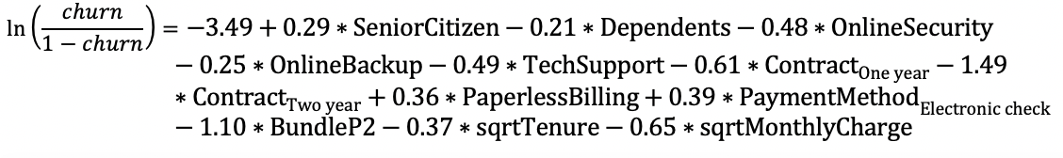

As our goal is to predict whether the customer will churn or not, we also tried logistic regression model, under the condition that the churn variable is not imbalanced, one with more than 5% counts of one level. Compared with KNN approach, logistic regression investigates the correlation between churn variable and other factors, which is a better approach for the company to understand its business performance. Meanwhile, with quantitative correlation, the company can predict the churn rate and take action in advance.

As the result shows[Table 1], the model shows 81% accuracy and 84% AUC[Table 3], reflecting that the model has good predictive performance. Among the 12 variables, there are 4 variables significantly increase the churn rate. Customers who are seniors, have average higher monthly charges, and use electronic check payment and paperless bill are more likely to churn. However, with longer contract, the churn rate will be largely decreased by 0.6 to 1.5 odds ratio. In addition, if the customer has bundling services and multiple products from the company, one’s churn rate will be further reduced by over 1.0 odds ratio.

# Recommendation and Managerial Implications

Our results indicate that there is significant room for churn rates reduction. First, payment method arrangements can be optimized. Churn sensibility to Paperless Bill and Electronic Check is convincing evidence that involuntary churn plays a significant role in overall retention. For example, customers under paperless Bills are more propense to ignore payment due date while those under longer contract tend to stay longer in order to benefit from associated discounts.

The company can adopt multiple actions to increase retention rates. First, despite its positive impact on churn, paperless bills should not be discouraged since it cuts printing costs and helps in waste reduction. Because customers that opt for paperless bill are usually digitally friendly, company should resort to new digital solutions target to reinforce customer awareness about payment due dates. For instance, text messages or online apps. In addition, auto-payment should be incentivized over electronic checks.

Second, customer that adheres to long term contract is more likely to become loyal. Thus, the company can offer progressive discounts in bills conditional to long-term contract adoption. Analytics team can use estimated model to assess if it is possible to craft deductions to the point that increases in retention rates compensate revenue losses.

Third, loyalty depends on how customers value experience. This is particularly true for internet customers. Enjoying multiple internet-related services has proven to appreciably reduce monthly churn. The company may promote better customer experience – and hence customer loyalty – by offering free full internet package sample for a limited time. Besides, the company must pay more attention to the quality and the price of streaming services since they are not helping in retaining customers.

Last, as expected bundling services is one of the most effective solutions to retain customers. Campaigns targeting one-service-subscription new customers should be encouraged. Since new customers paying high charges are more willing to drop, a good strategy may be to tie such campaigns to price rebates, so retention rates can be impacted through more than one channel simultaneously.

# Conclusion

The customer churn behavior is associated with their demographic and account information, as well as their connection with the company. The findings in the data guide the company to reduce churn rate by initiating loyalty promotion, optimizing payment methods, and targeting on younger customer groups. Furthermore, deeper analysis including customer segmentation and product test could be facilitated for more insights on product differentiation if with more data.

# Appendix

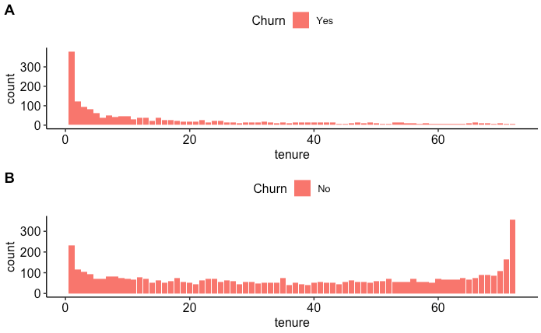

Figure 1

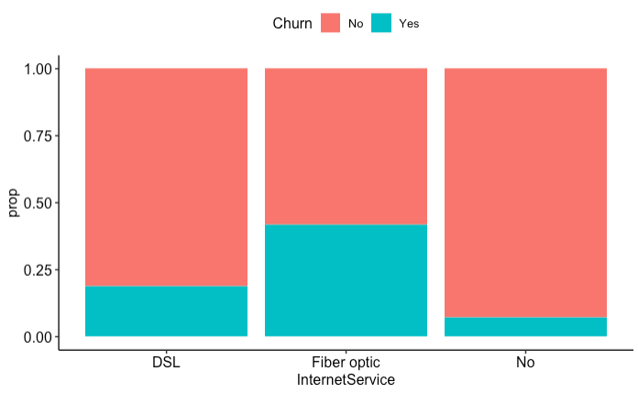

Figure 2.1

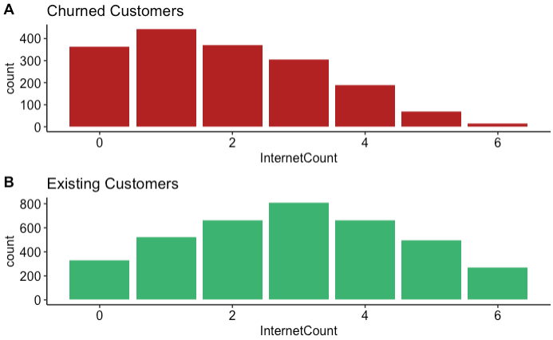

Figure 2.2

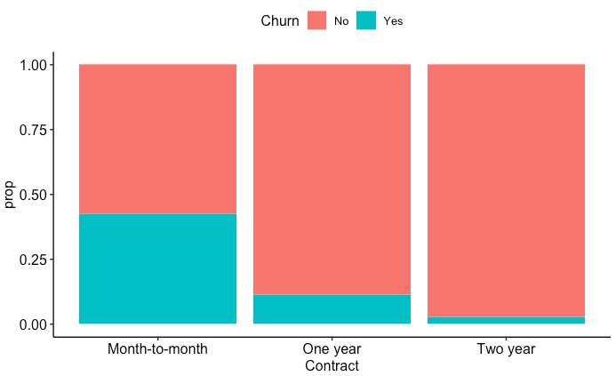

Figure 3

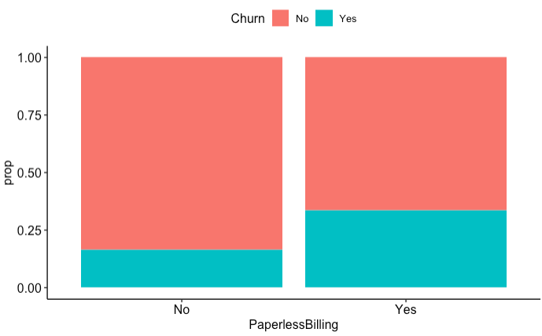

Figure 4

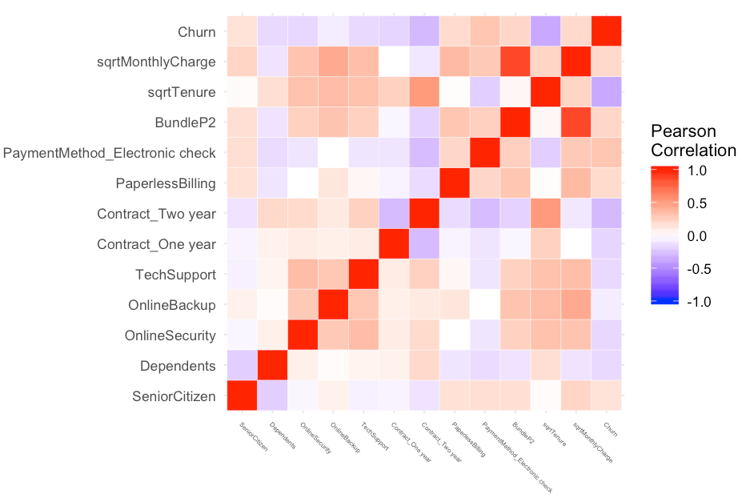

Figure 5

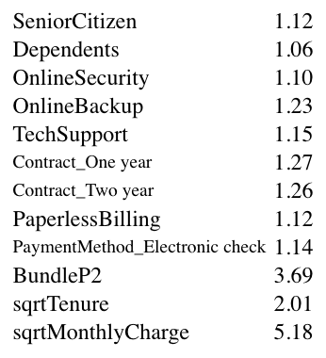

Table 1: Evidence of No multicollinearity

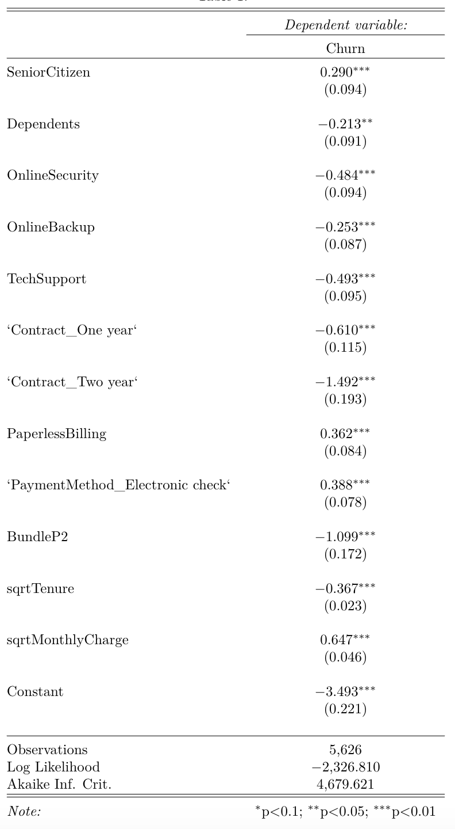

Table 2

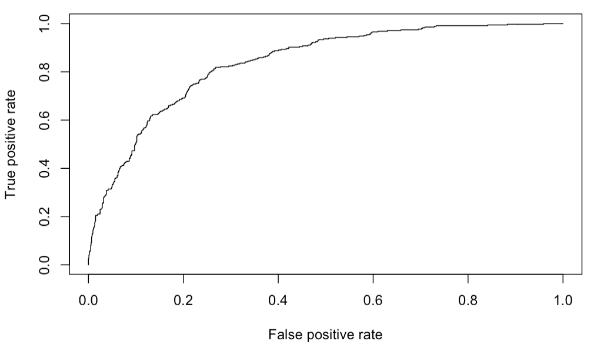

Table 3

# References

[1] CollegeGrad LLC. Telecommunications Industry. Retrieved from

<https://collegegrad.com/industries/telecommunications>

[2] Ray Sheffer. (2015, Jan 16). An overview of the US telecom industry. Retrieved from

<https://marketrealist.com/2015/01/overview-us-telecom-industry/>

[3] Marguerite Reardon. (2006, May 30). Cable goes for the quadruple play. Retrieved from <https://www.cnet.com/news/cable-goes-for-the-quadruple-play/>

[4] Nicole McCormick. The Rise of New Bundles. Retrieved from

<https://ovum.informa.com/~/media/Informa-Shop-Window/TMT/Files/Ovum-Telco-Services-Bundle.pdf>

[5] Barbara McKinney. (2016, Feb 7). How Helpful Is Multi Channel Marketing in Generating Telecom Leads For You. Retrieved from <https://www.business2community.com/marketing/helpful-multi-channel-marketing-generating-telecom-leads-01444482>

[6] Adham Fahmi. Know Me Now: The Nuts and Bolts Behind Real-time Marketing. Retrieved from <https://www.ttec.com/articles/know-me-now-nuts-and-bolts-behind-real-time-marketing>

[7] OECD Competition Committee. (1995). Competition in Telecommunications. Retrieved from <https://www.oecd.org/daf/competition/sectors/1920287.pdf>

[8] Phil Wilson. From monopoly to competition. Retrieved from

<https://www2.deloitte.com/us/en/insights/industry/telecommunications/three-rules-telecom-firms-exceptional-performance.html>

[9] Guido Frisiani. (2017, Oct). Difficult times for operators call for questioning old orthodoxies to win. Retrieved from

<https://www.mckinsey.com/industries/technology-media-and-telecommunications/our-insights/hello-mobile-operators-this-is-your-age-of-disruption-calling>

[10] Arthur Middleton Hughes. (2007, Jan 24). Churn reduction in the telecom industry. Retrived from <https://www.dmnews.com/data/news/13068687/churn-reduction-in-the-telecom-industry>

[11] Catherine Haslam. (2018, Jun). Inspire loyalty with customer lifecycle management. Retrived from <https://inform.tmforum.org/research-reports/inspire-loyalty-customer-lifecycle-management/?mkt_tok=eyJpIjoiTWpBNE56QXhabU5qTW1VMiIsInQiOiJlSEhURUZWanlCbUwrajBqQ2U2K0ltU012d05xTEkrNjQreElNRzFXRW12KytcL3N1d3l2QnJocXpZcGpBbmhPcDJiWVdiTndDTk5tTFJ6Y2d1RndVRVE9PSJ9>

[12] Pallav Jain and Kushan Surana. (2017, Dec). Reducing churn in telecom through advanced analytics. Retrived from <https://www.mckinsey.com/industries/technology-media-and-telecommunications/our-insights/reducing-churn-in-telecom-through-advanced-analytics>

[13] Telco Customer Churn. Retrived from <https://www.kaggle.com/blastchar/telco-customer-churn>

[14] Kairanga James Masharia. (2012, Jul). Churn Prediction Modelling In Mobile Telecommunications Industry. Retrived from <https://pdfs.semanticscholar.org/5dfe/33029f44ab8448e77ac22b480a2b1cd29709.pdf>

[15] Fusebill Inc. The Impact of Billing on Churn and Lifetime Value. Retrived from <https://blog.fusebill.com/2013/02/28/the-impact-of-billing-on-churn-and-lifetime-value>